CMPS 350 Web Development Fundamentals Spring 2021

**Final Exam**

|  |  |
| --- | --- |
| **Student Name** | Yousef qumatah |
| **Student Id** | 1704721 |
| **Email** | Yq1704721@qu.edu.qa |

**Grading Rubric - - In the *Functionality* column please specify either: *Working (completed x%)*, *Not Working (completed x%)* or *Not done*.**

|  |  |  |  |  |
| --- | --- | --- | --- | --- |
| Criteria | % | Functionality* | Quality of the implementation | Score |
| * 1. Created the models with their validation | 15 | 15 |  |  |
| * 1. Implemented the Repository class with all the required methods | 30 | 30 |  |  |
| * 1. Implemented the Service class with all the required methods | 15 | 15 |  |  |
| * 1. Implemented the router.js | 10 | 10 |  |  |
| * 1. Implemented app.js | 10 | 10 |  |  |
| 1. Connected the client app to the server | 20 | 10 |  |  |
| Total | 100 | 90 |  |  |
| Copying and/or plagiarism or not being able to explain or answer questions about the implementation | -100 |  |  |  |

**Possible grading for functionality**:

* ***Complete and Working*** (get 70% of the assigned grade),
* ***Complete and Not working*** (lose 40% of assigned grade)
* ***Not done*** get 0.
* The remaining grade is assigned to the quality of the implementation.
* Must submit screenshots in this **Testing-GradingSheet.docx** (otherwise - 10pts).

## Testing evidence (You should provide a screenshot of your work)

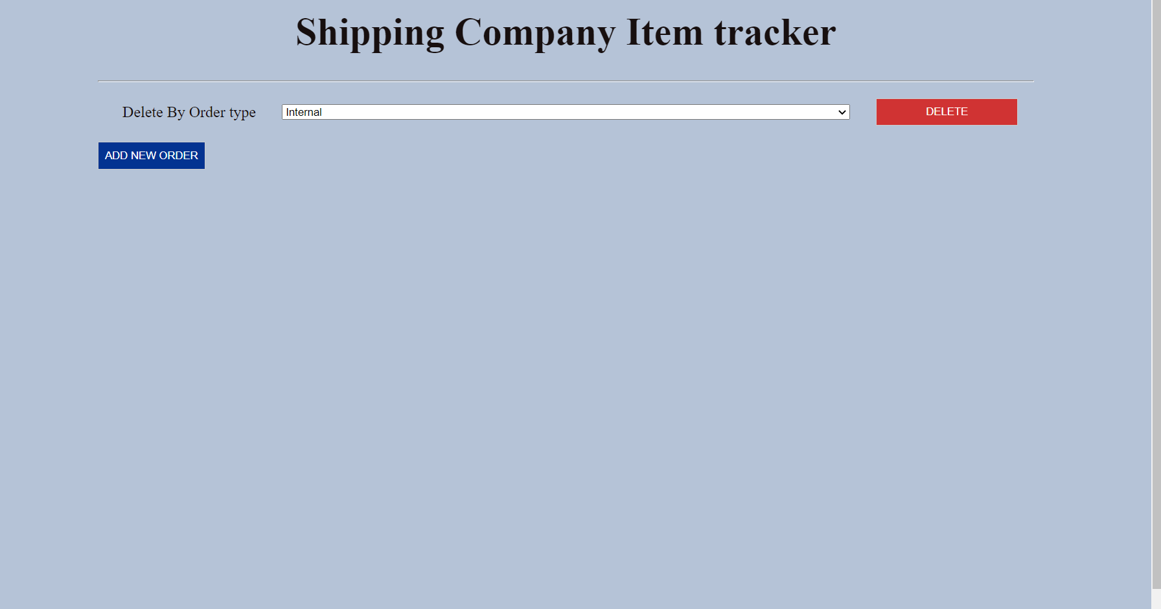

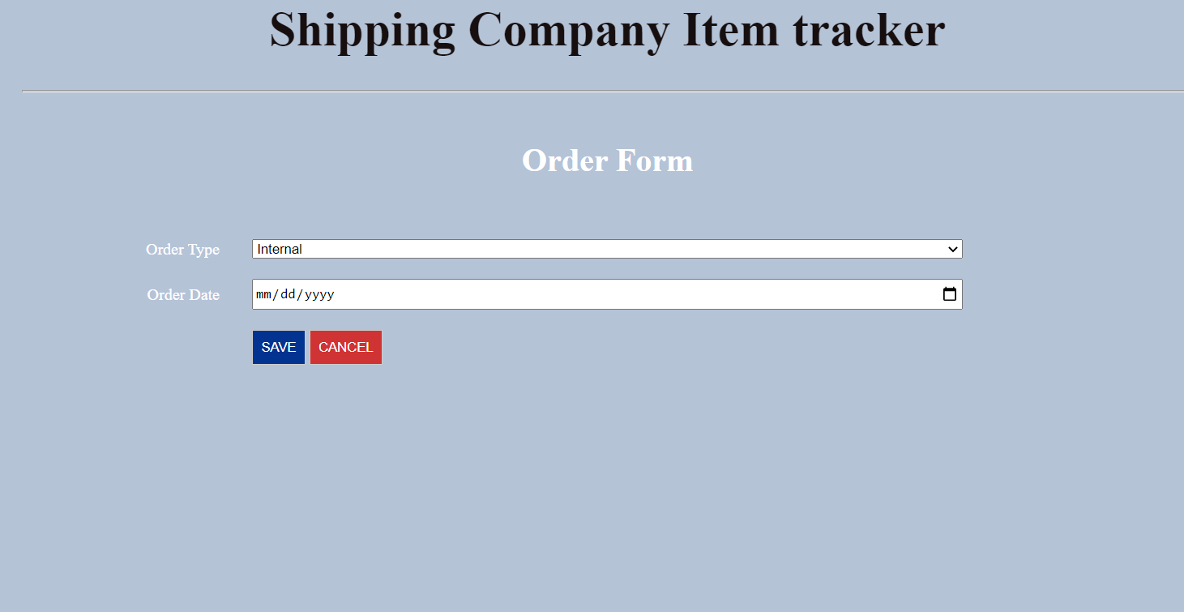

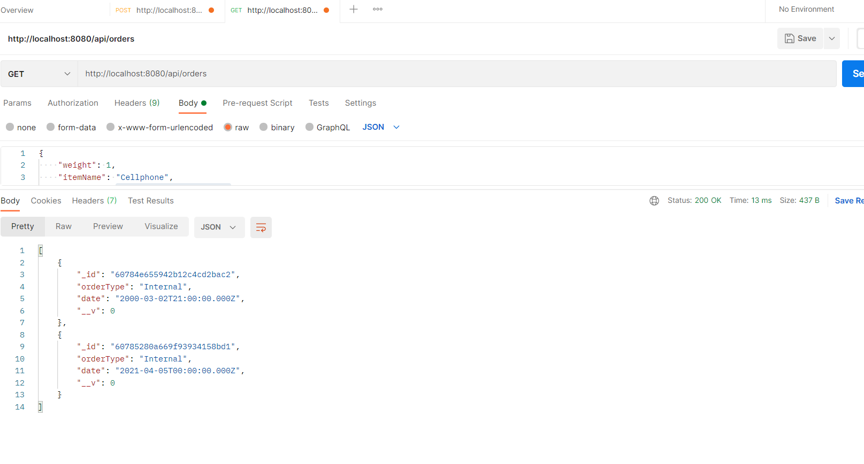

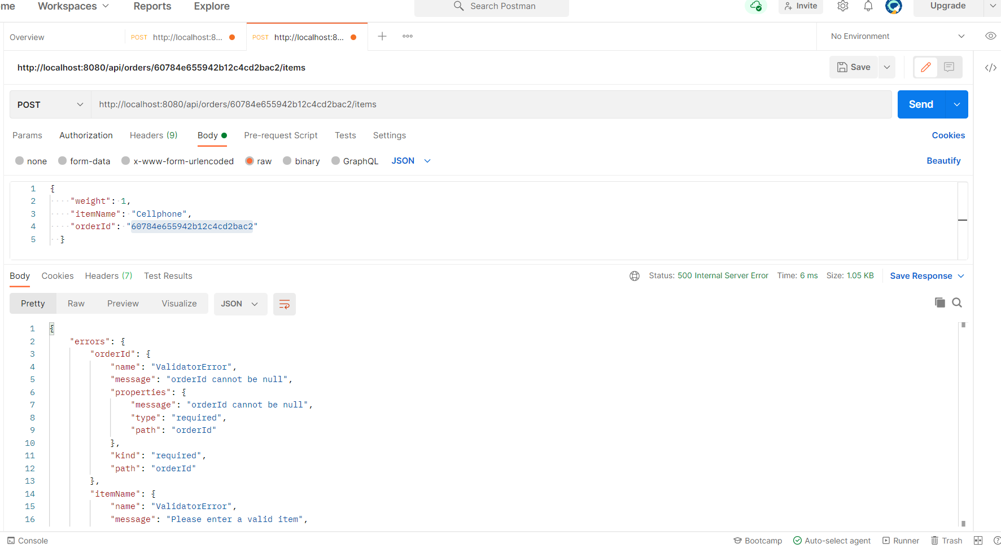

I cant provide for items postman because this post method doesn’t work for some reason.